|  |  |
| --- | --- |
|  |  |

New Delhi, India

January 23, 2025

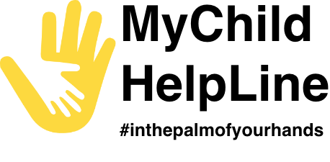

USER GUIDE

MyChild Helpline Mobile Application

**Table of Contents**

CHAPTER 1: INTRODUCTION 3

CHAPTER 2: STEPS TO INSTALL 4

CHAPTER 3: REGISTER 5

CHAPTER 4: MY SPACE 8

4.1 CALL US 8

4.2 REQUEST FOR COUNSELLING 9

4.3 MY DIARY 11

4.4 MY CHILL SPOT 12

4.5 ARCADE 13

4.6 U-MATTER MENTAL HEALTH CHATLINE 14

CHAPTER 5: INFORMATION KIOSK 15

5.1 MY RIGHTS 15

5.2 PARENTING HUB 16

5.3 GOVERNMENT SERVICES 17

5.4 RESOURCES 18

5.5 MYCHILD HELPLINE 19

5.6 UNICEF EASTERN CARIBBEAN AREA 20

CHAPTER 6: HELPING HAND 21

CHAPTER 7: NOTIFICATION 22

CHAPTER 8: ACCESSIBILITY 23

CHAPTER 9: SETTINGS 24

# CHAPTER 1: INTRODUCTION

The MyChild Helpline mobile application is developed for both the Apple and Android mobile phones and available at App Store and Play Store for download. It comprises of the following modules:

* Register
* My Space
  + Call Us
  + Request for Counselling
  + My Diary
  + My Chill Spot
  + Arcade
  + U Matter Mental Health Chatline
* Information Kiosk
  + My Rights
  + The Parenting Hub
  + Government Services
  + Resources
  + My Child Helpline
  + Nearby Places
  + UNICEF Eastern Caribbean Areas
* Helping Hand
* Notifications
* Accessibility
* Settings

This user guide provides instructions to help users understand and navigate the MyChild helpline mobile application. From Chapter 3 onwards, it explains the steps to use the various modules.

# CHAPTER 2: STEPS TO INSTALL

Follow the below steps to install the application -

* Download the app from the **Google Play Store** for Android devices or the **Apple App Store** for iOS devices. Alternatively, you can download the appropriate installation file (.APK for Android or. IPA for iOS).
* Install the file by following the on-screen instructions specific to your device.
* Once the installation is complete, tap the app icon to open the MyChild Helpline app *(Refer to figures 2.1, 2.2, and 2.3).*

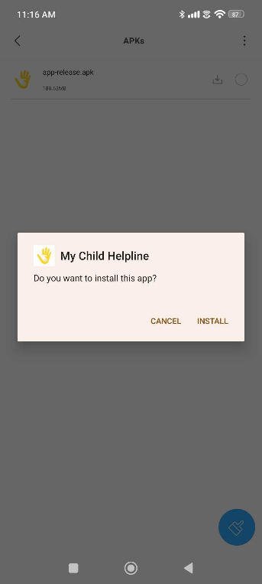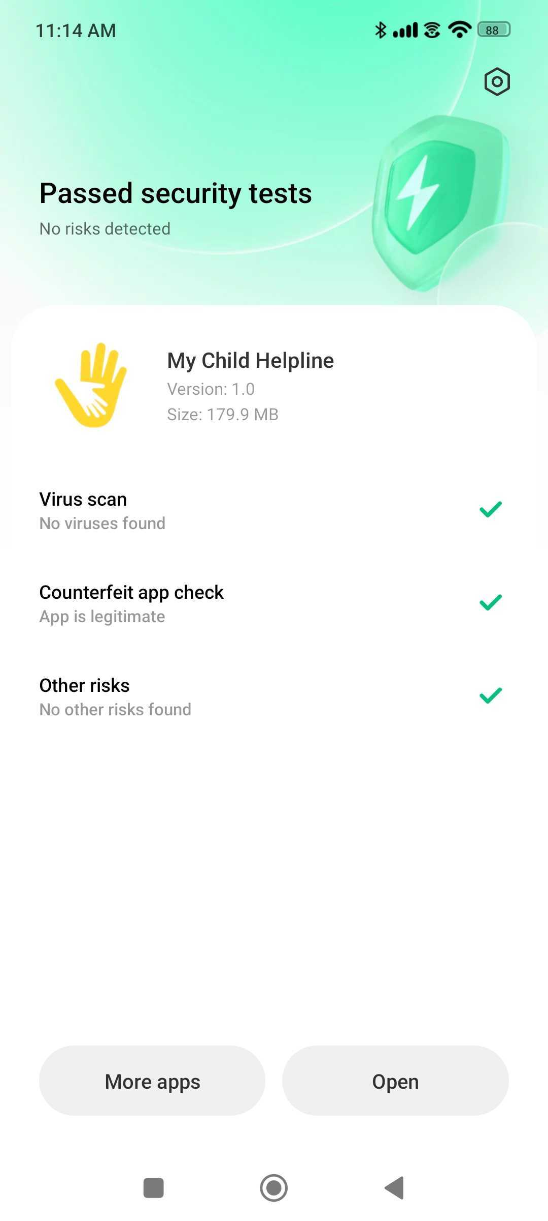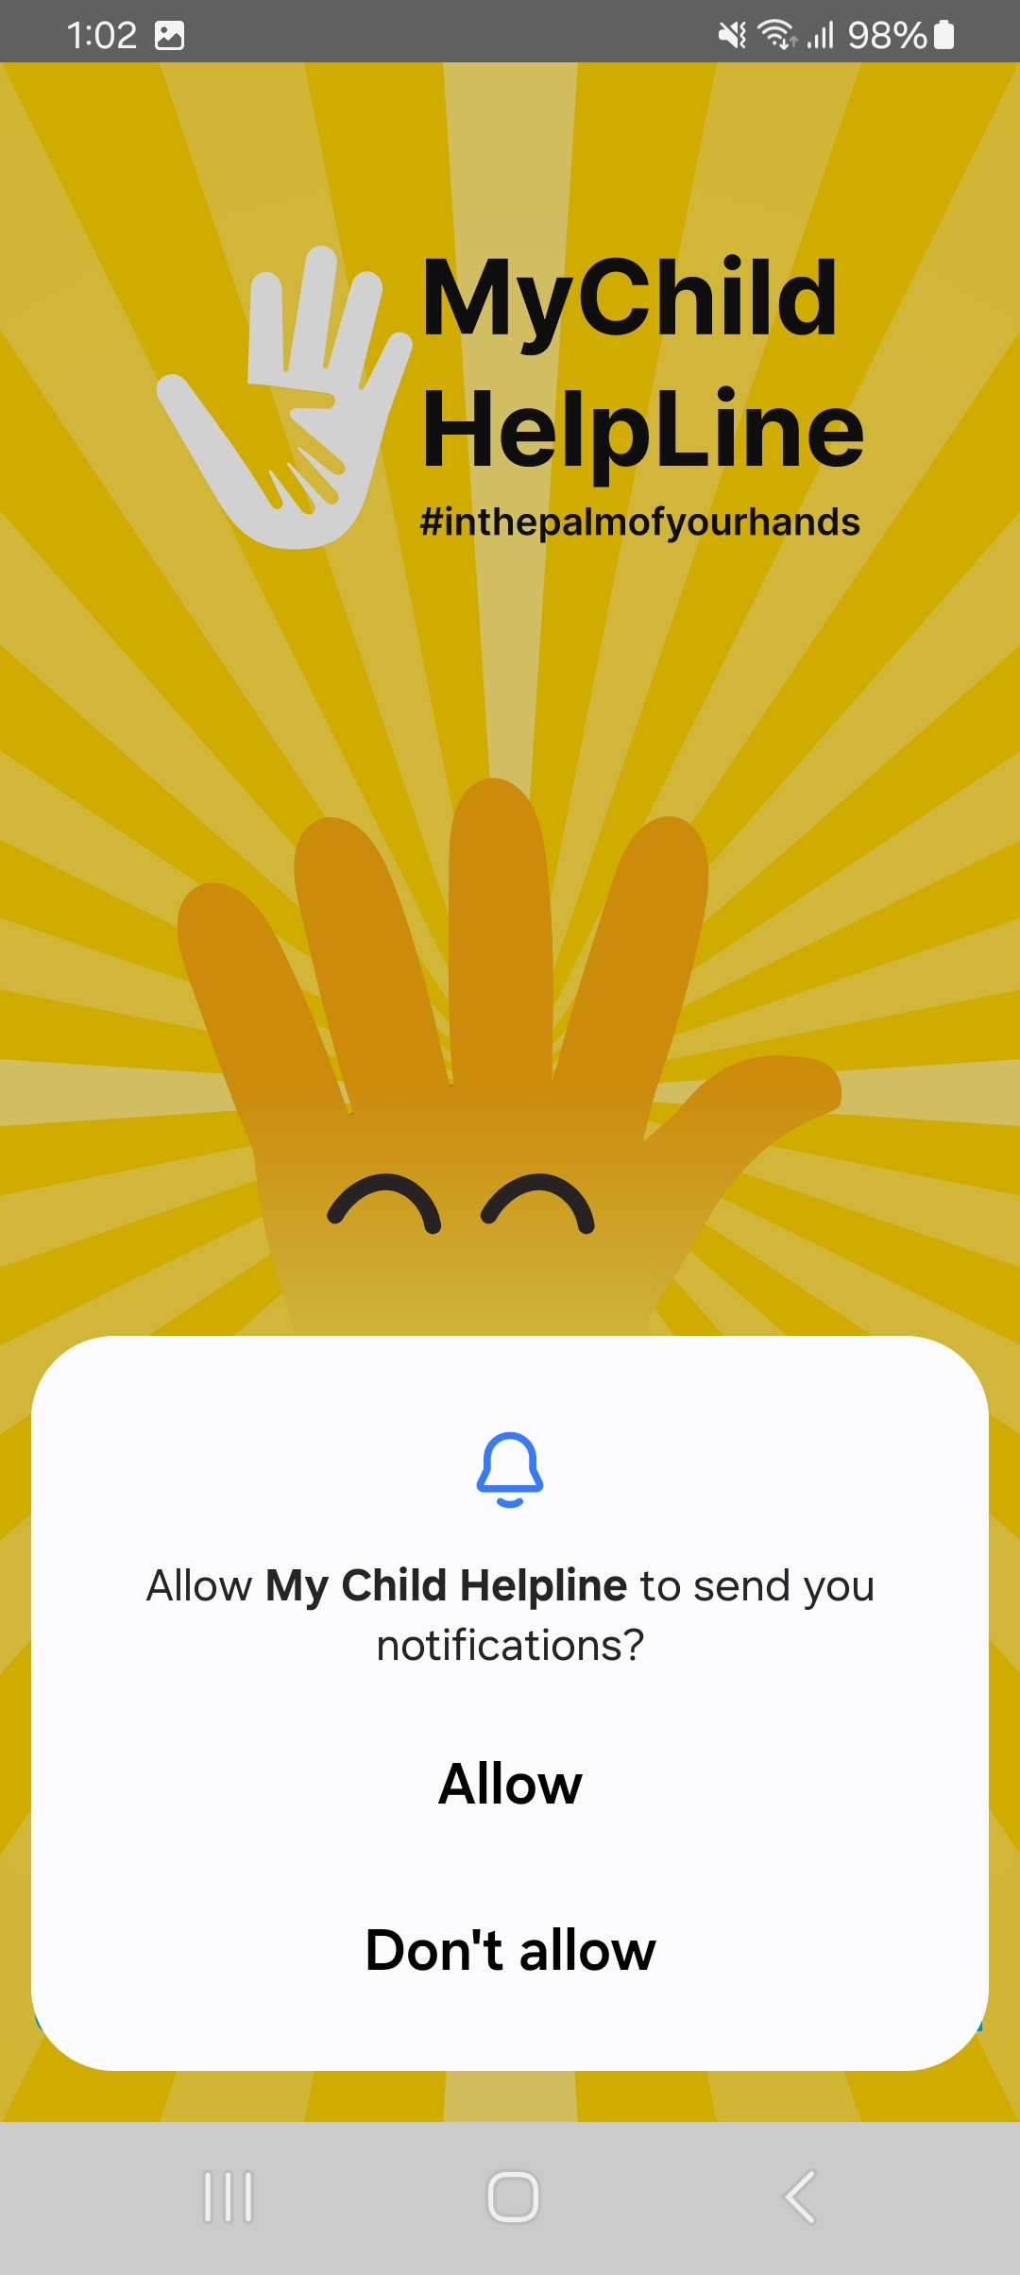

*Figure 2.1*

*Figure 2.2*

*Figure 2.3*

# CHAPTER 3: REGISTER

The Register module enables users to create an account by providing basic details like name, date of birth, preferred language, gender, country, and district. Users can also personalize their profile by uploading a display picture or selecting and customizing an avatar. Below is a step-by-step guide to registering on the mobile application.

**Step 1:** Tap the **App Icon** after completing the installation. A splash screen will appear, followed by slider images.

**Step 2:** Tap the “**Skip**” option located at the bottom-right corner of the slider images to bypass them and proceed directly to the registration page *(Refer to figure 3.1, 3.2 and 3.3).*

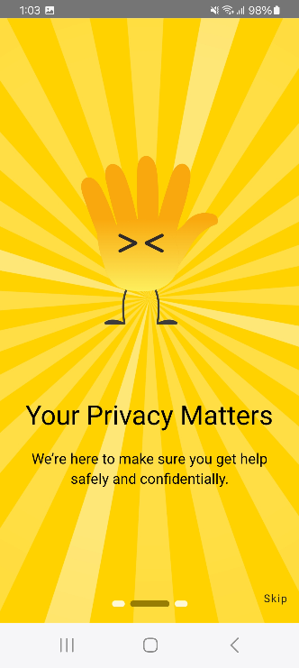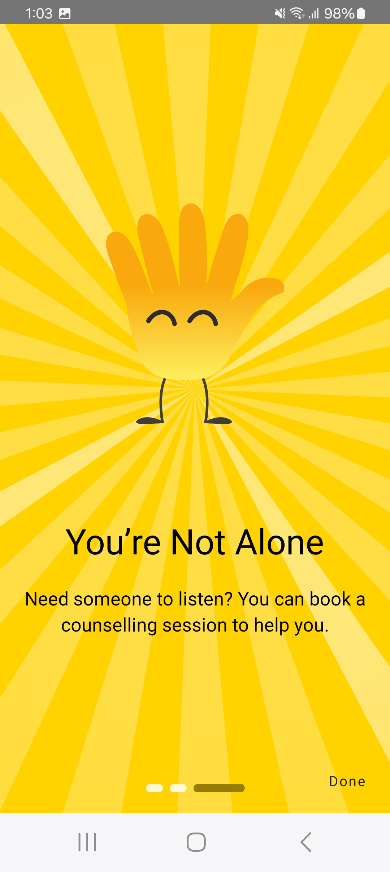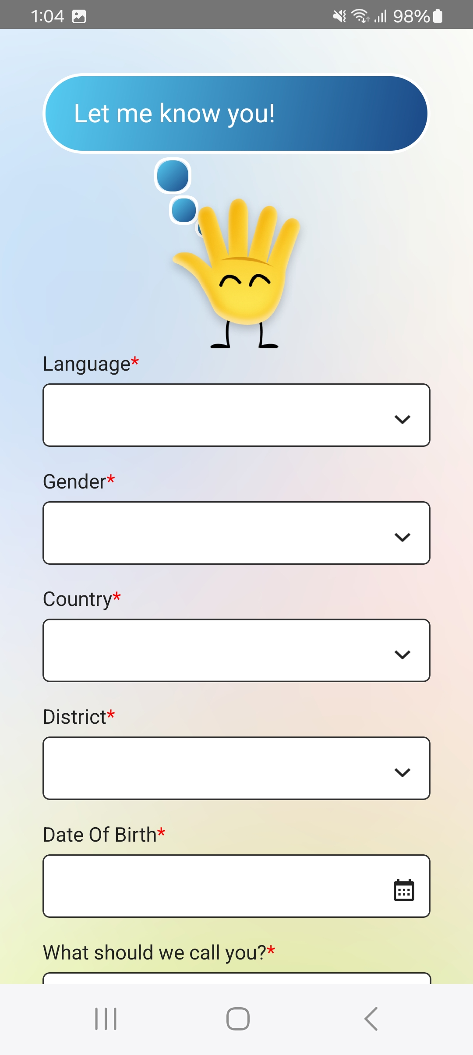

*Figure 3.1*

*Figure 3.2*

*Figure 3.3*

**Step 3:** Enter or select the following mandatory details *(Refer to figure 3.3):*

* Language
* Gender
* Country
* District
* Date of Birth
* What should we call you? (Username)

**Step 4:** Tap on the "**Choose Your Avatar**" option to customize your avatar and set it as your display picture (Refer to figure 3.4, 3.5 and 3.6). Alternatively, tap on the "**Upload an Image**" option to capture a photo and set it as your display picture.

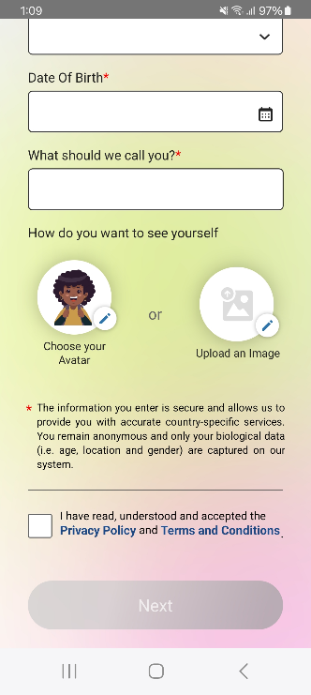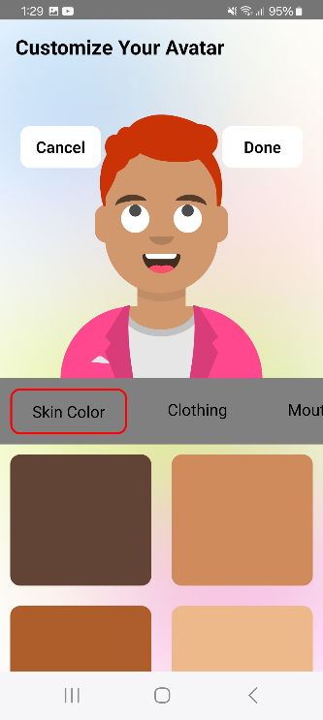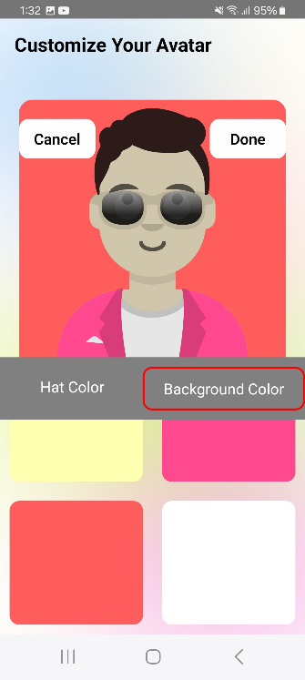

Figure 3.4

Figure 3.5

Figure 3.6

**Step 5:** Tap the checkbox to confirm that you have read and understood the privacy policy. Then, tap on the "**Next**" button to complete the registration process.

**Step 6:** After successful registration, you'll be greeted by a mascot named Helping Hand, who will ask about your current mood *(Refer to figure 3.7)*.

**Step 7:** Tap on the mood that best reflects how you're feeling right now. You will receive a list of modules tailored to your selected mood *(Refer to figure 3.8).* If you prefer not to select any of the available modules, tap the **Cross** icon in the top-right corner.

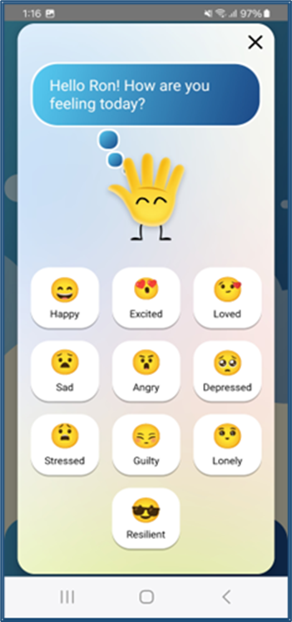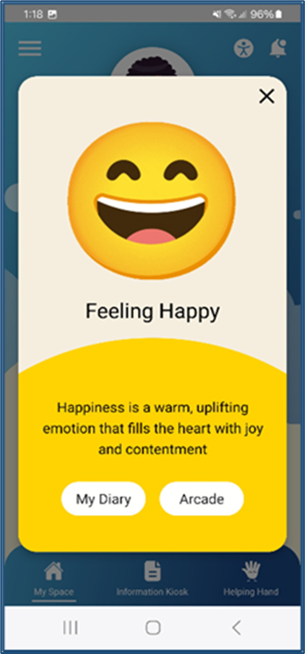

*Figure 3.7*

*Figure 3.8*

# CHAPTER 4: MY SPACE

The **My Space** module serves as the homepage providing access to key features such as the Call Us, Request for Counselling, My Diary, My Chill Spot, and an Arcade with interactive games like Tic Tac Toe, Bounce, and Puzzle. Below is a step-by-step guide to use this module.

## 4.1 CALL US

**Step 1**: Tap on the **Call Us** module to reach a dedicated hotline for immediate support *(Refer to figure 4.1.1 and 4.1.2).*

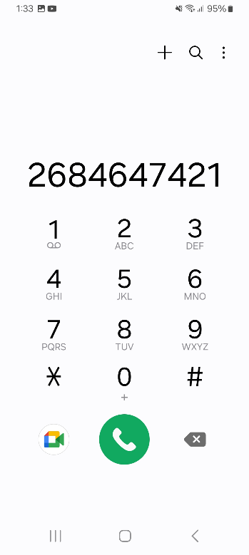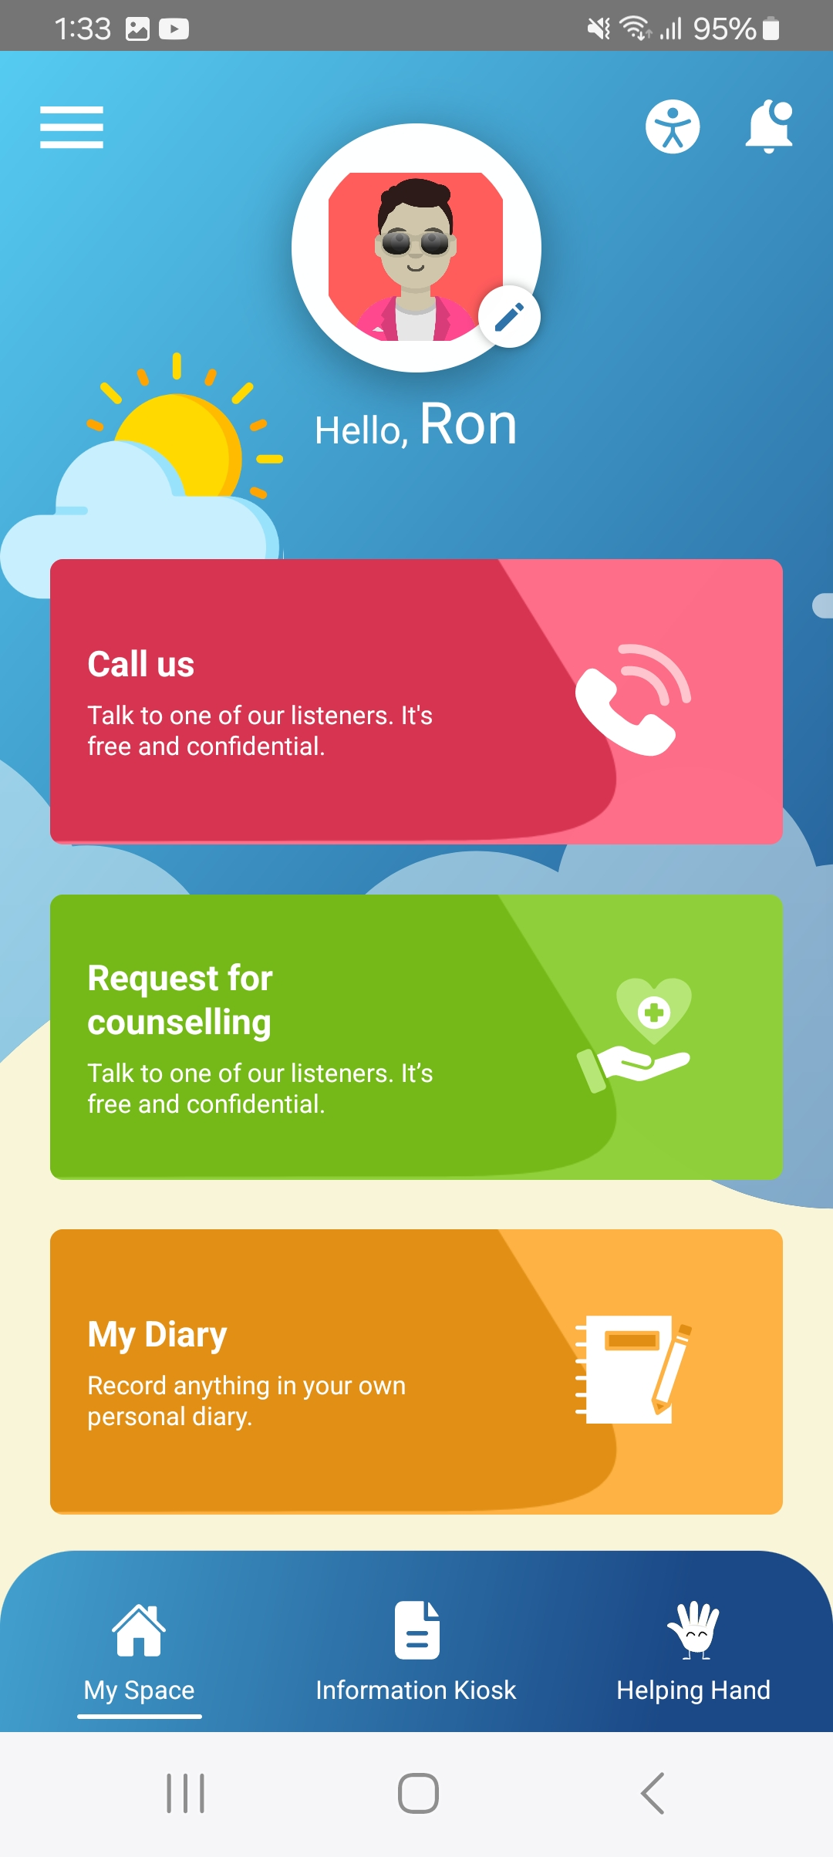

*Figure 4.1.1*

Figure 4.1.2

## 4.2 REQUEST FOR COUNSELLING

**Step 1:** Tap on the **Request for Counselling** module to schedule a session with a professional counsellor *(Refer to figure 4.2.1)*.

**Step 2:** Enter or select the following mandatory details to book your appointment *(Refer to figure 4.2.2)*:

* Appointment Date
* What led you to request counselling?
* First Name
* Last Name
* Telephone Number
* Message

**Step 3:** After filling in all the required details, tap “**Book Your Counselling”** to confirm your appointment or tap on the “Cancel” option to discard *(Refer to figure 4.2.3).*

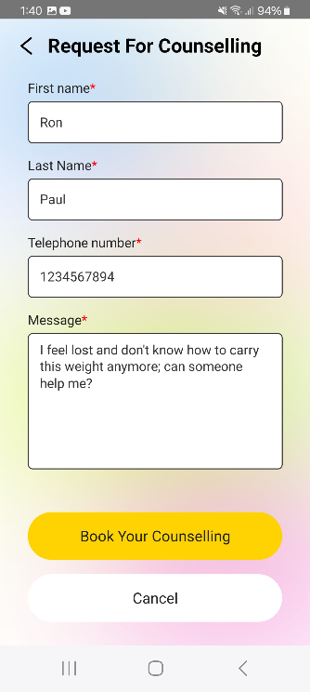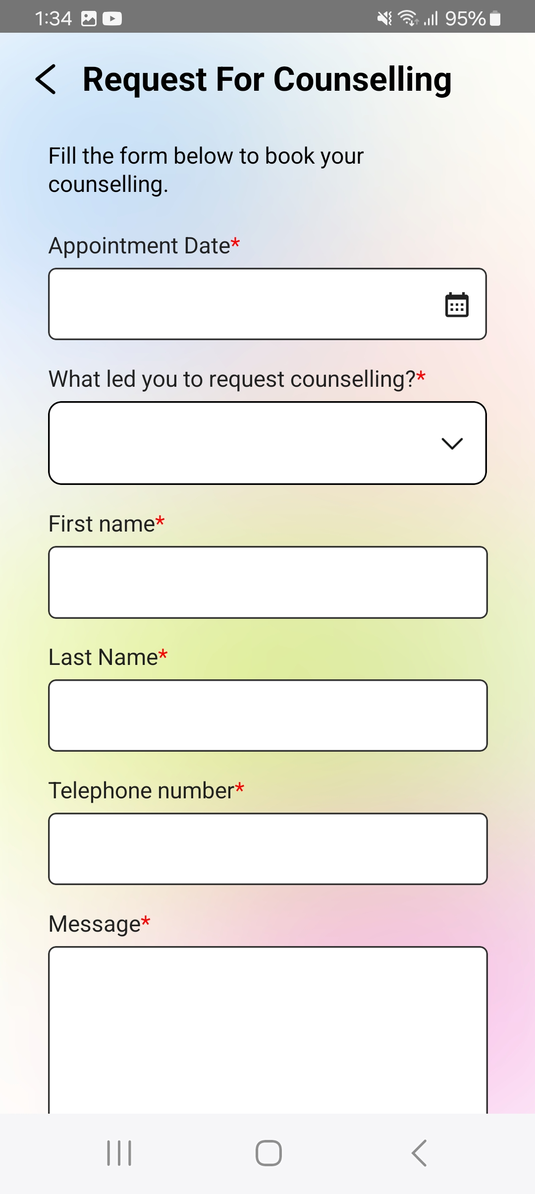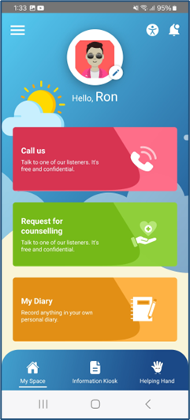

*Figure 4.2.1*

*Figure 4.2.2*

*Figure 4.2.3*

**Step 4:** Once the request is submitted, a confirmation pop-up will appear, confirming that your request has been successfully submitted. Tap the **Ok** button to close the pop-up *(Refer to figure 4.2.4)*.

**Step 5:** Following the previous pop-up, another pop-up will appear asking if you need any immediate support, with the options "**Call Us**" or **"Cancel**" *(Refer to figure 4.2.5)****.***

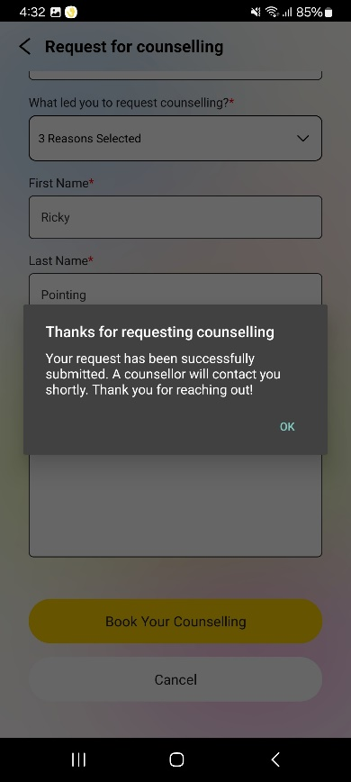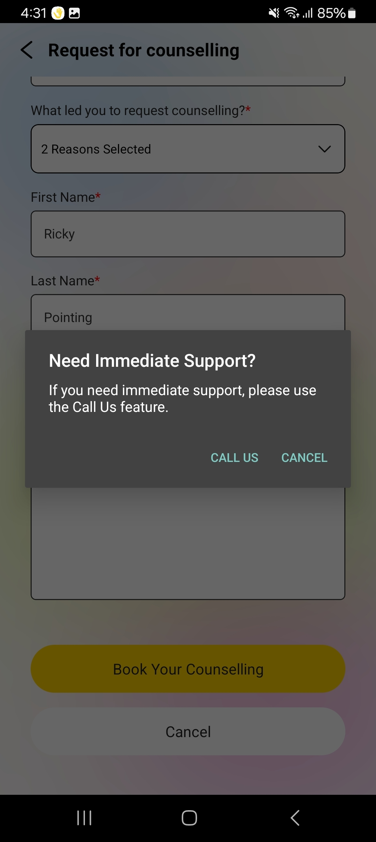

*Figure 4.2.4*

*Figure 4.2.5*

## 4.3 MY DIARY

**Step 1:** Tap on the **My Diary** module to begin journaling. Tap on the “**Plus”** button to add a new entry in the diary by entering a title and the message *(Refer to figure 4.3.1 and 4.3.2).*

**Step 2:** Tap on the three dots available with each record in the diary to “**Share**” or “**Delete**” the entry *(Refer to figure 4.3.3).*

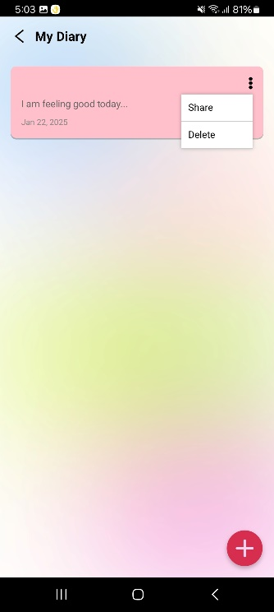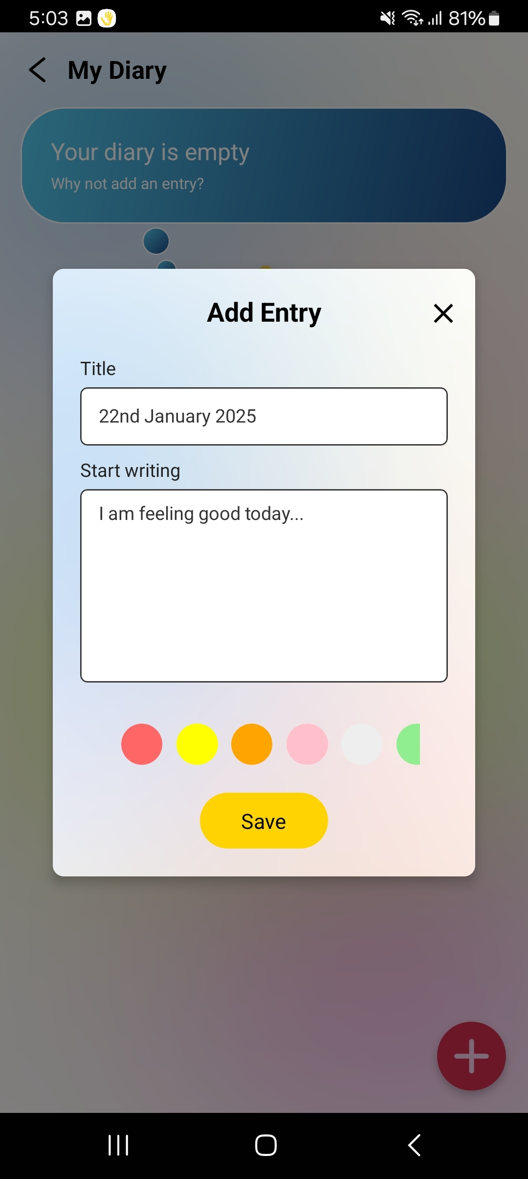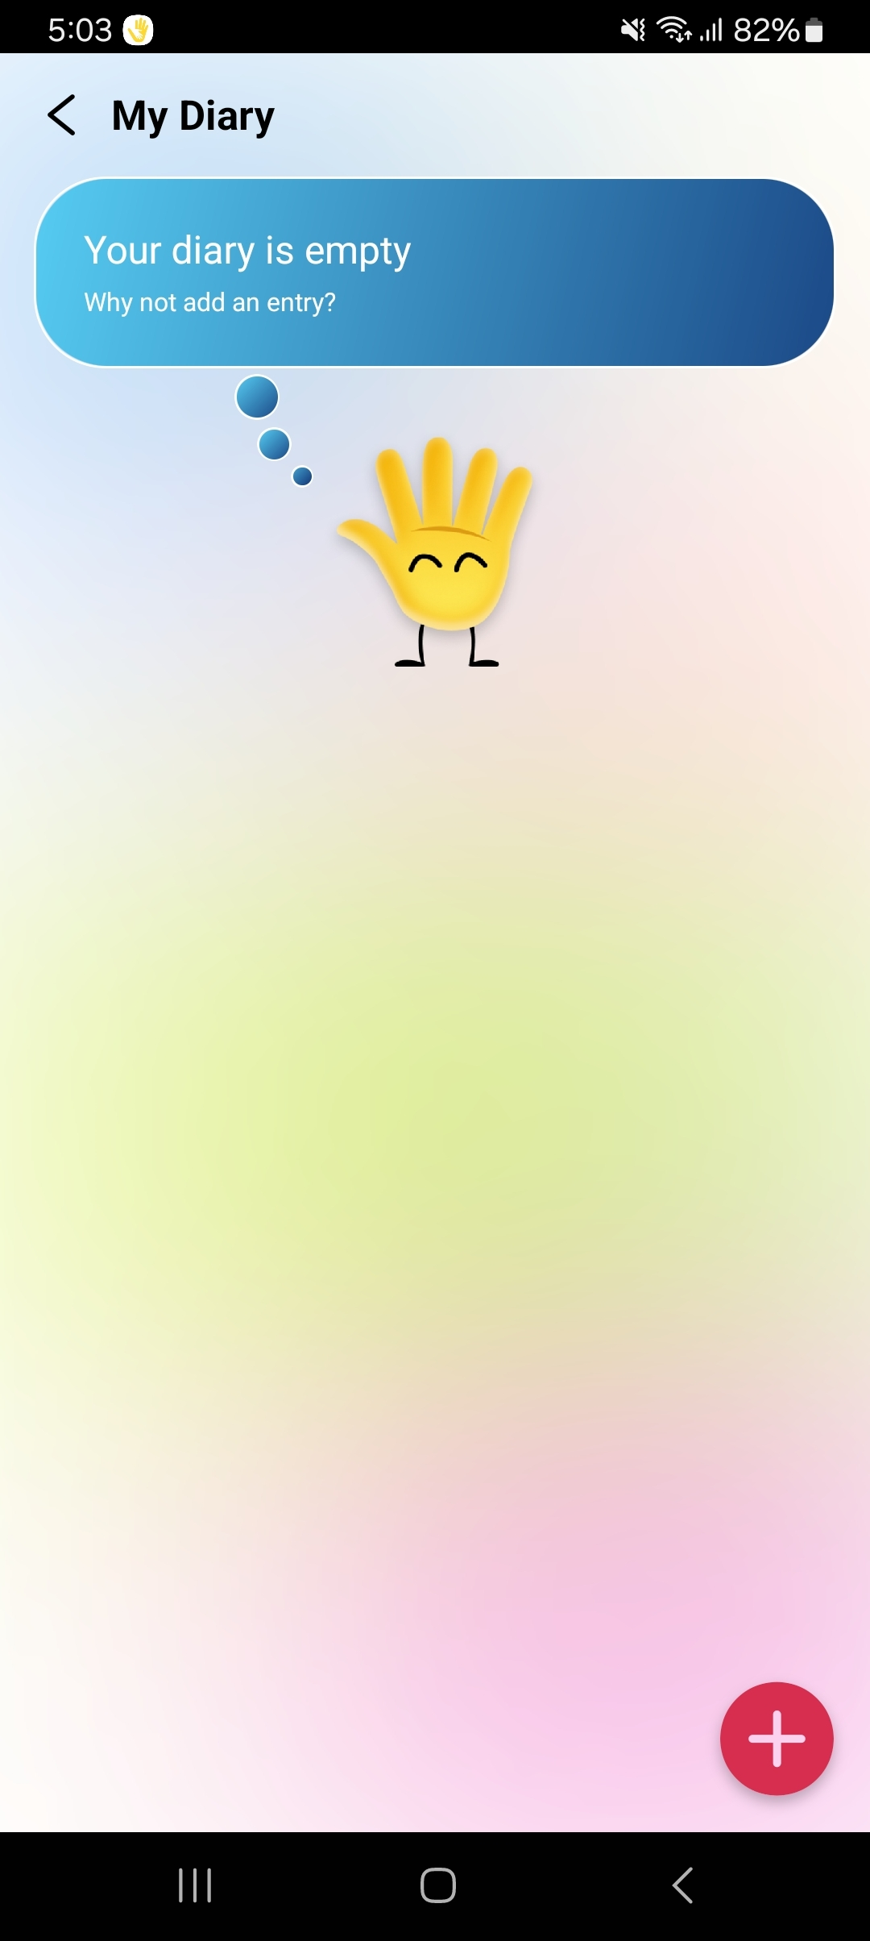

*Figure 4.3.1*

*Figure 4.3.2*

*Figure 4.3.3*

## 4.4 MY CHILL SPOT

**Step 1:** Tap on the **My Chill Spot** module to engage in some calming *activities (Refer to figure 4.4.1).*

**Step 2:** Tap on the “**Breath**” option to start a breathing exercise and “**Counting from 10**” option to begin a calming counting exercise *(as shown in Figure 4.4.2).*

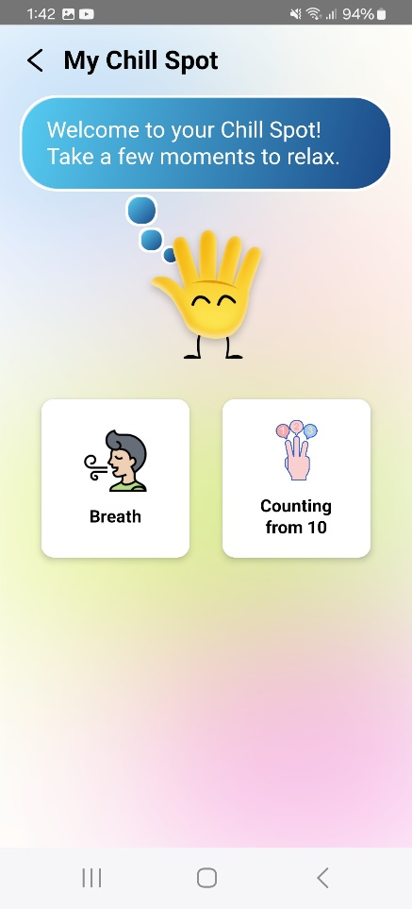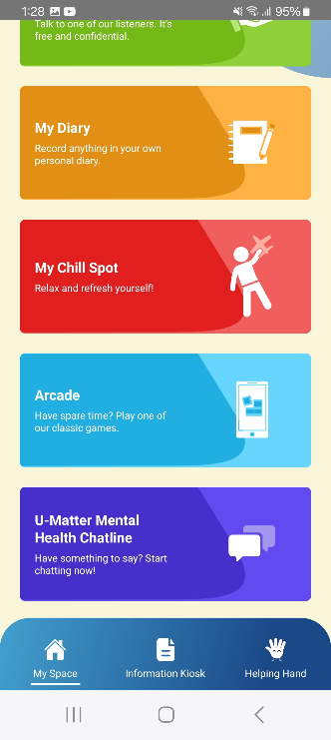

*Figure 4.4.1*

*Figure 4.4.2*

## 4.5 ARCADE

**Step 1:** Tap on the **Arcade** module to play interactive games *(Refer to figure 4.5.1).*

**Step 2:** Tap on any of the following game options to start playing - **Tic-Tac-Toe**, **Puzzle**, or **Bounce** *(as shown in Figure 4.5.1 and 4.5.2).*

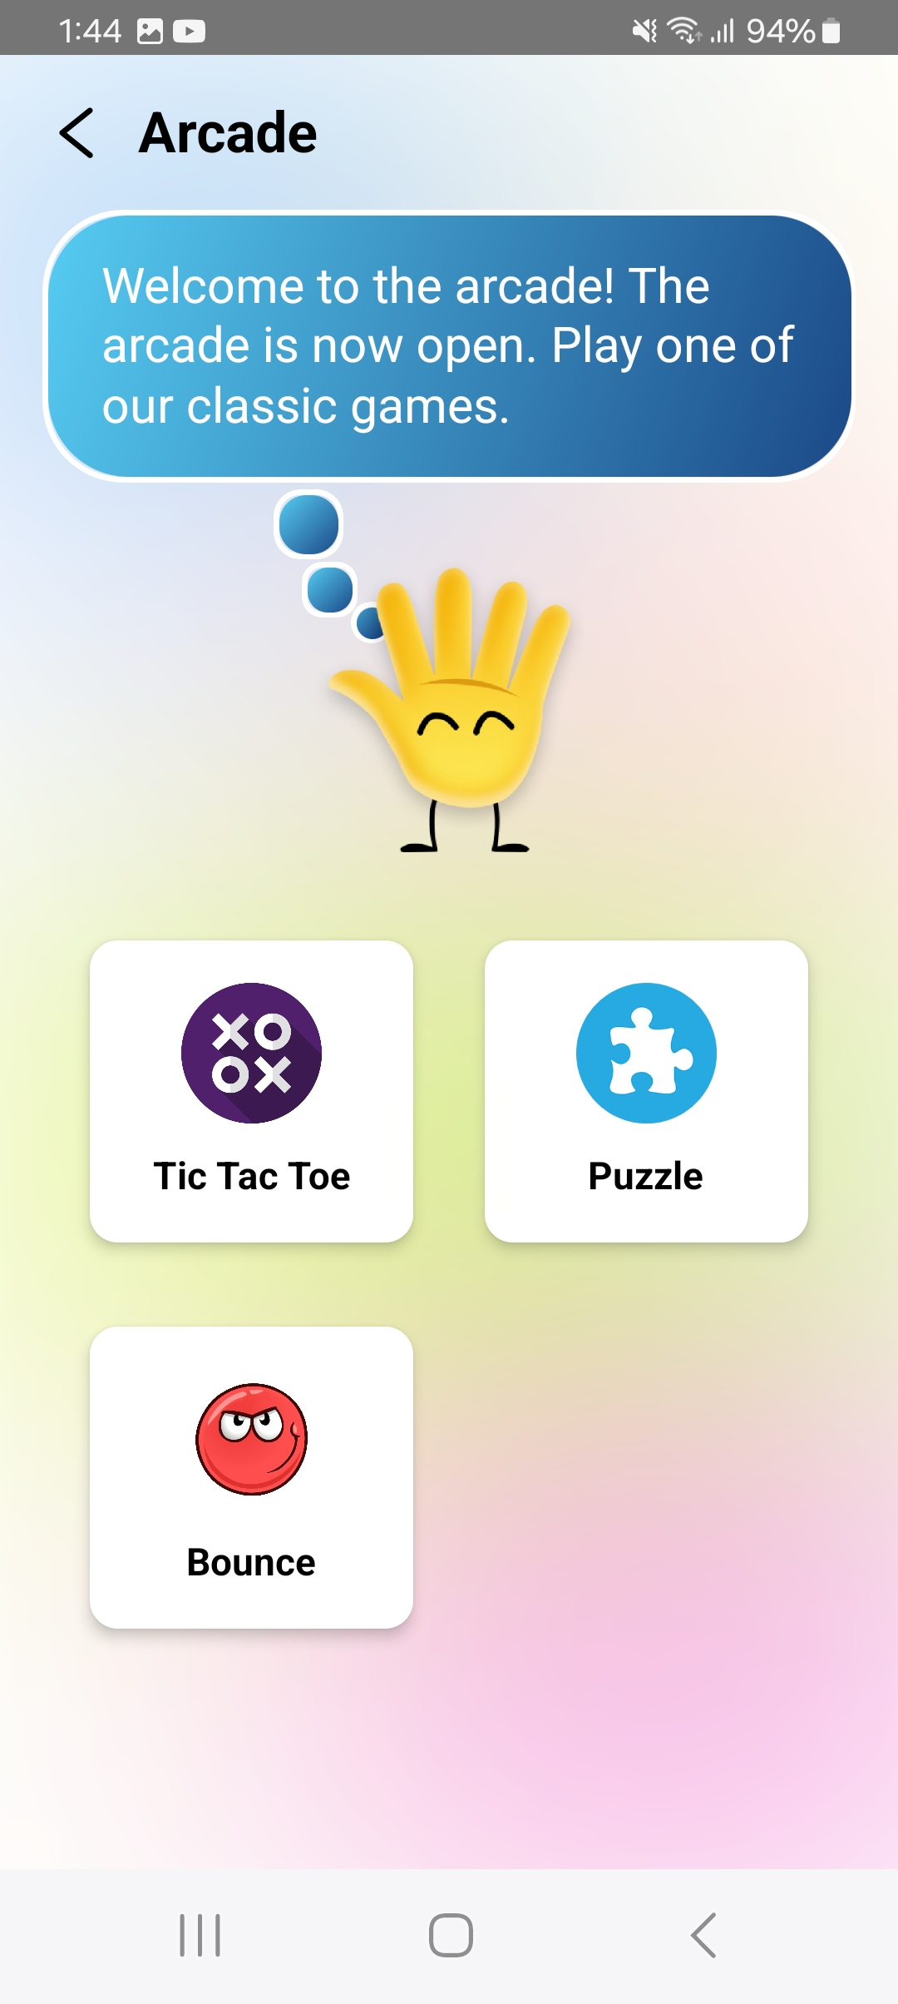

*Figure 4.5.1*

*Figure 4.5.2*

## 4.6 U-MATTER MENTAL HEALTH CHATLINE

**Step 1:** Tap on **U-Matter Mental Health chatline** to connect with a support executive from the respective country.

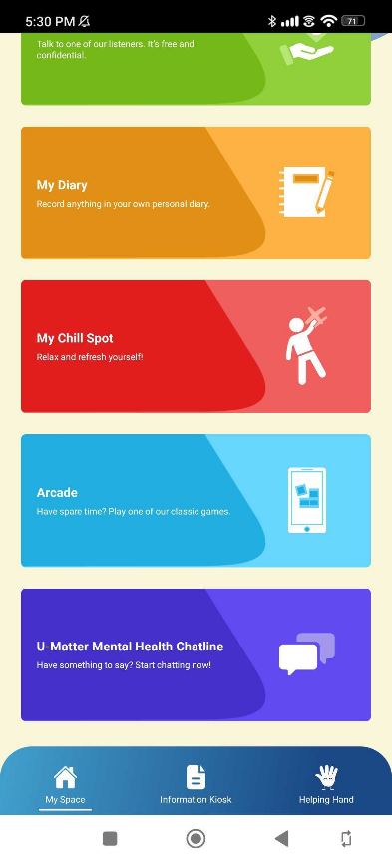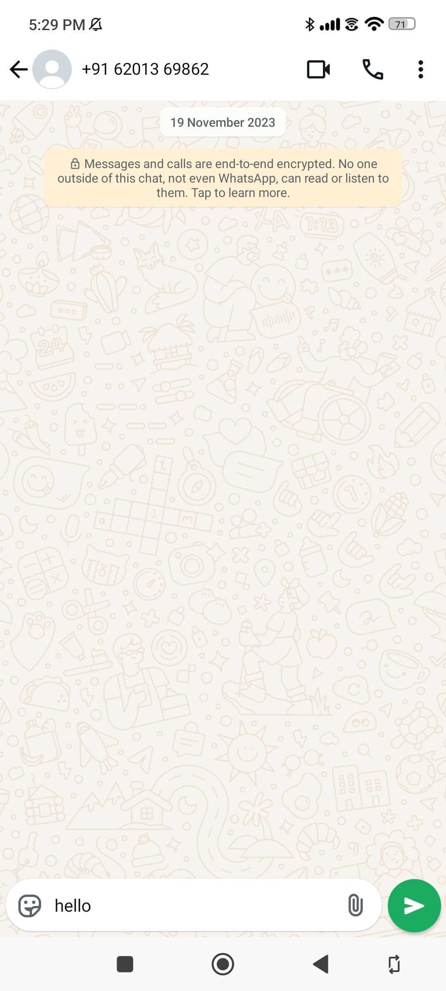

*Figure 4.6.1*

*Figure 4.6.2*

# CHAPTER 5: INFORMATION KIOSK

The **Information Kiosk** module serves as a content repository for users. This module has following sub-modules - My Rights, The Parenting Hub, Government Services, Resources, MyChild Helpline, and UNICEF Eastern Caribbean Areas. Below is a step-by-step guide to use this module.

## 5.1 MY RIGHTS

**Step 1:** Tap on the **My Rights** module to access a comprehensive view of child rights *(Refer to figure 5.1.1).*

**Step 2:** Tap on the **"Play"** button to listen to the written content as audio *(Refer to figure 5.1.2).*

**Step 3:** Tap on the **"Let's Go"** option to read the detailed child rights *(Refer to figure 5.1.3).*

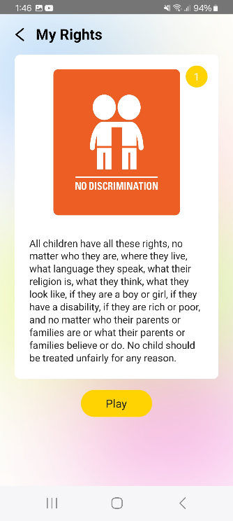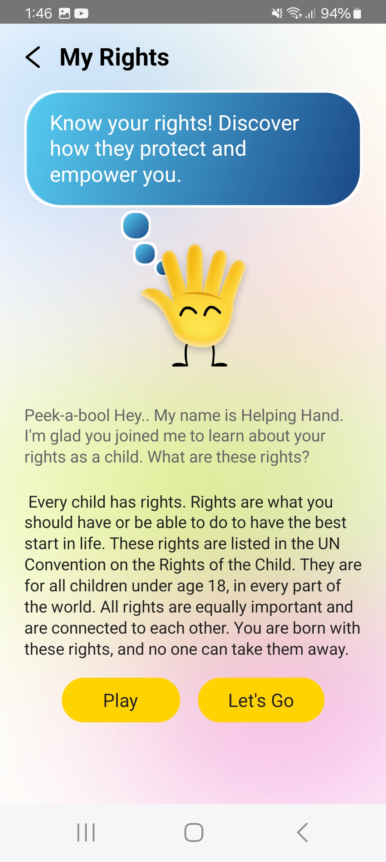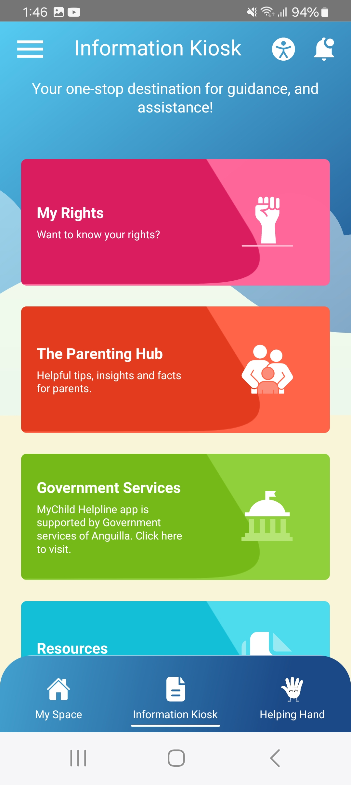

*Figure 5.1.1*

*Figure 5.1.2*

*Figure 5.1.3*

## 5.2 PARENTING HUB

**Step 1:** Tap on “**The Parenting Hub”** module, which will redirect you to the UNICEF Parenting page *(Refer to figure 5.2.1 and 5.2.2).*

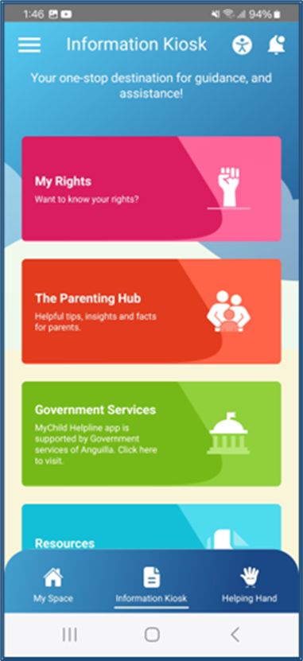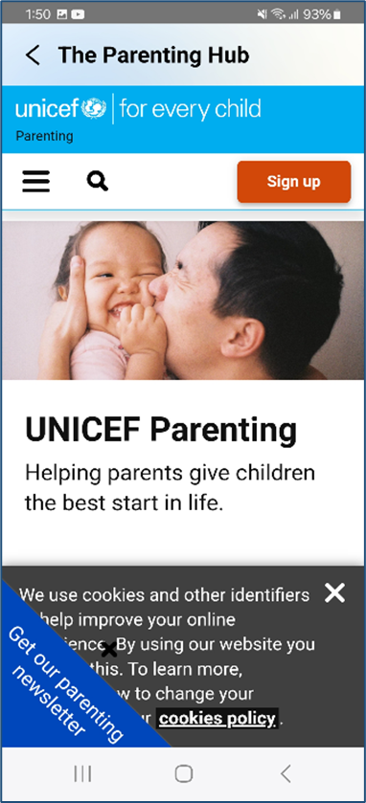

*Figure 5.2.1*

*Figure 5.2.2*

## 5.3 GOVERNMENT SERVICES

**Step 1:** Tap on the “**Government Services”** module which will redirect you to the government services page *(as shown in Figure 5.3.1 and 5.3.2).*

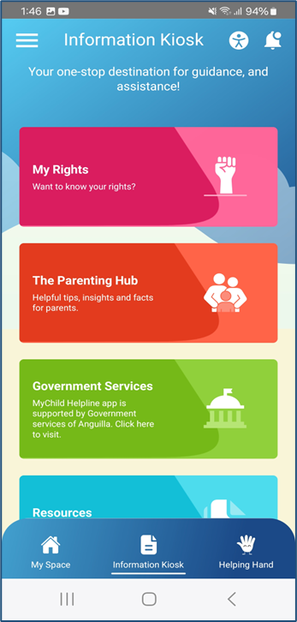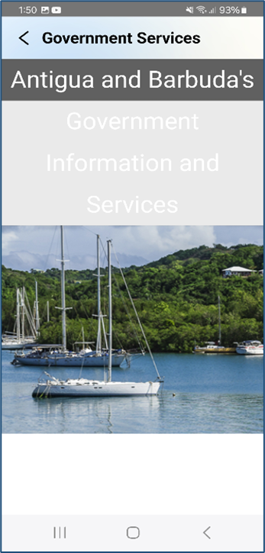

*Figure 5.3.1*

*Figure 5.3.2*

## 5.4 RESOURCES

**Step 1:** Tap on the **Resources** module to access various services related to children's health, education, and safety *(Refer to figure 5.4.1).*

**Step 2:** Tap on any of the services to view its contact information and other details such as location and website *(Refer to figure 5.4.2 and 5.4.3).*

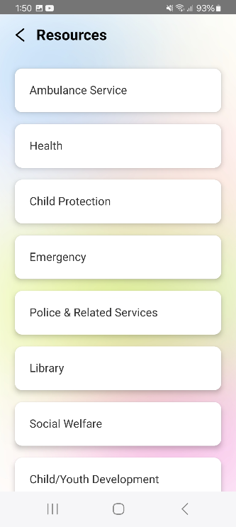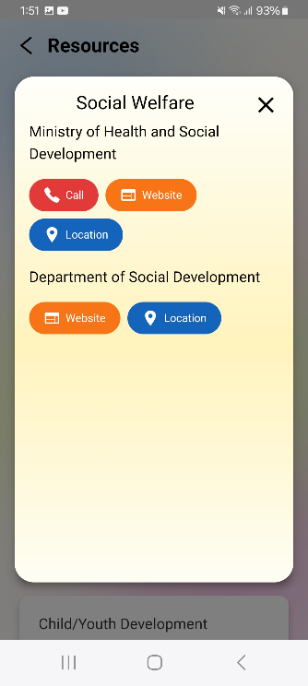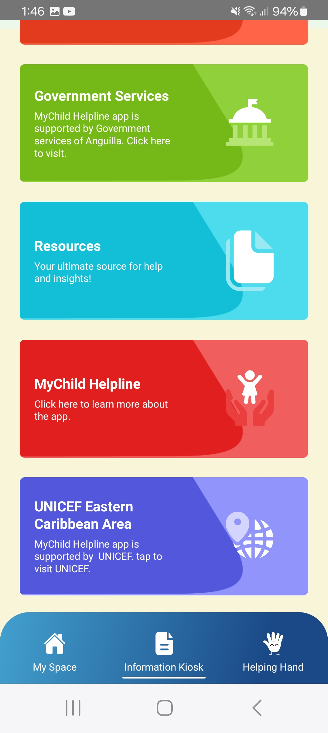

*Figure 5.4.1*

*Figure 5.4.2*

*Figure 5.4.3*

## 5.5 MYCHILD HELPLINE

**Step 1:** Tap on the **MyChild Helpline** module to access the MyChild Helpline website *(Refer to figure 5.5.1 and 5.5.2)*

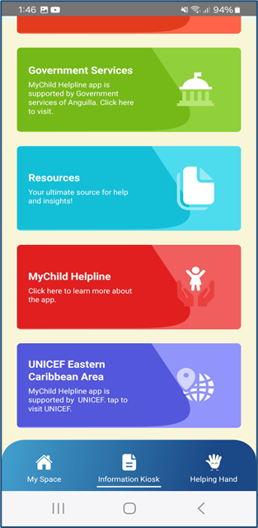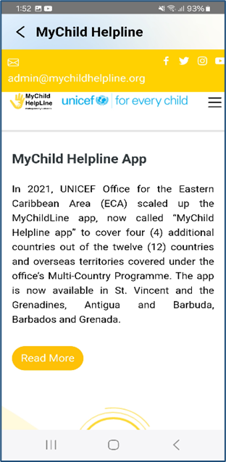

*Figure 5.5.1*

*Figure 5.5.2*

## 5.6 UNICEF EASTERN CARIBBEAN AREA

**Step 1:** Tap on the **UNICEF Eastern Caribbean Area** module to access the UNICEF Eastern Caribbean website *(as shown in Figure 5.6.1 and 5.6.2).*

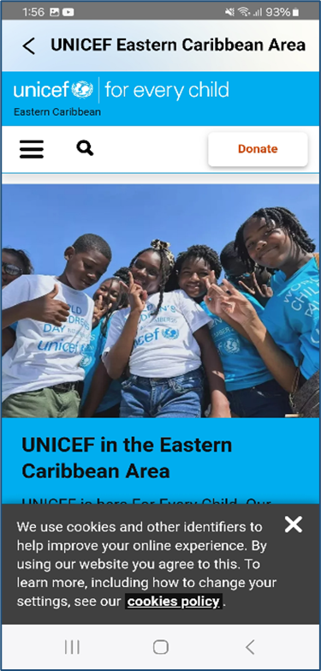

*Figure 5.6.1*

*Figure 5.6.2*

# CHAPTER 6: HELPING HAND

The **Helping Hand** module features an AI-enabled chatbot that enhances user engagement and navigation. It serves as a conversational agent powered by artificial intelligence technology like natural language processing (NLP). Below is a step-by-step guide to use this module.

**Step 1:** Tap on the **Helping Hand** option from the main tab to start interacting with the chatbot *(Refer to figure 6.1 and 6.2).*

**Step 2:** Enter your message in the textbox available at the bottom and tap on the **send** icon.

**Step 3:** Follow the chatbot's suggestions and feel free to ask any follow-up questions.

**Step 4:** Tap the **Back arrow** to close the chatbot when you're done.

*Figure 6.3*

*Figure 6.2*

*Figure 6.1*

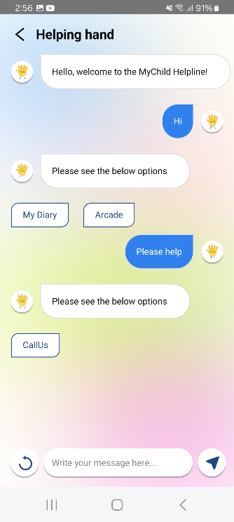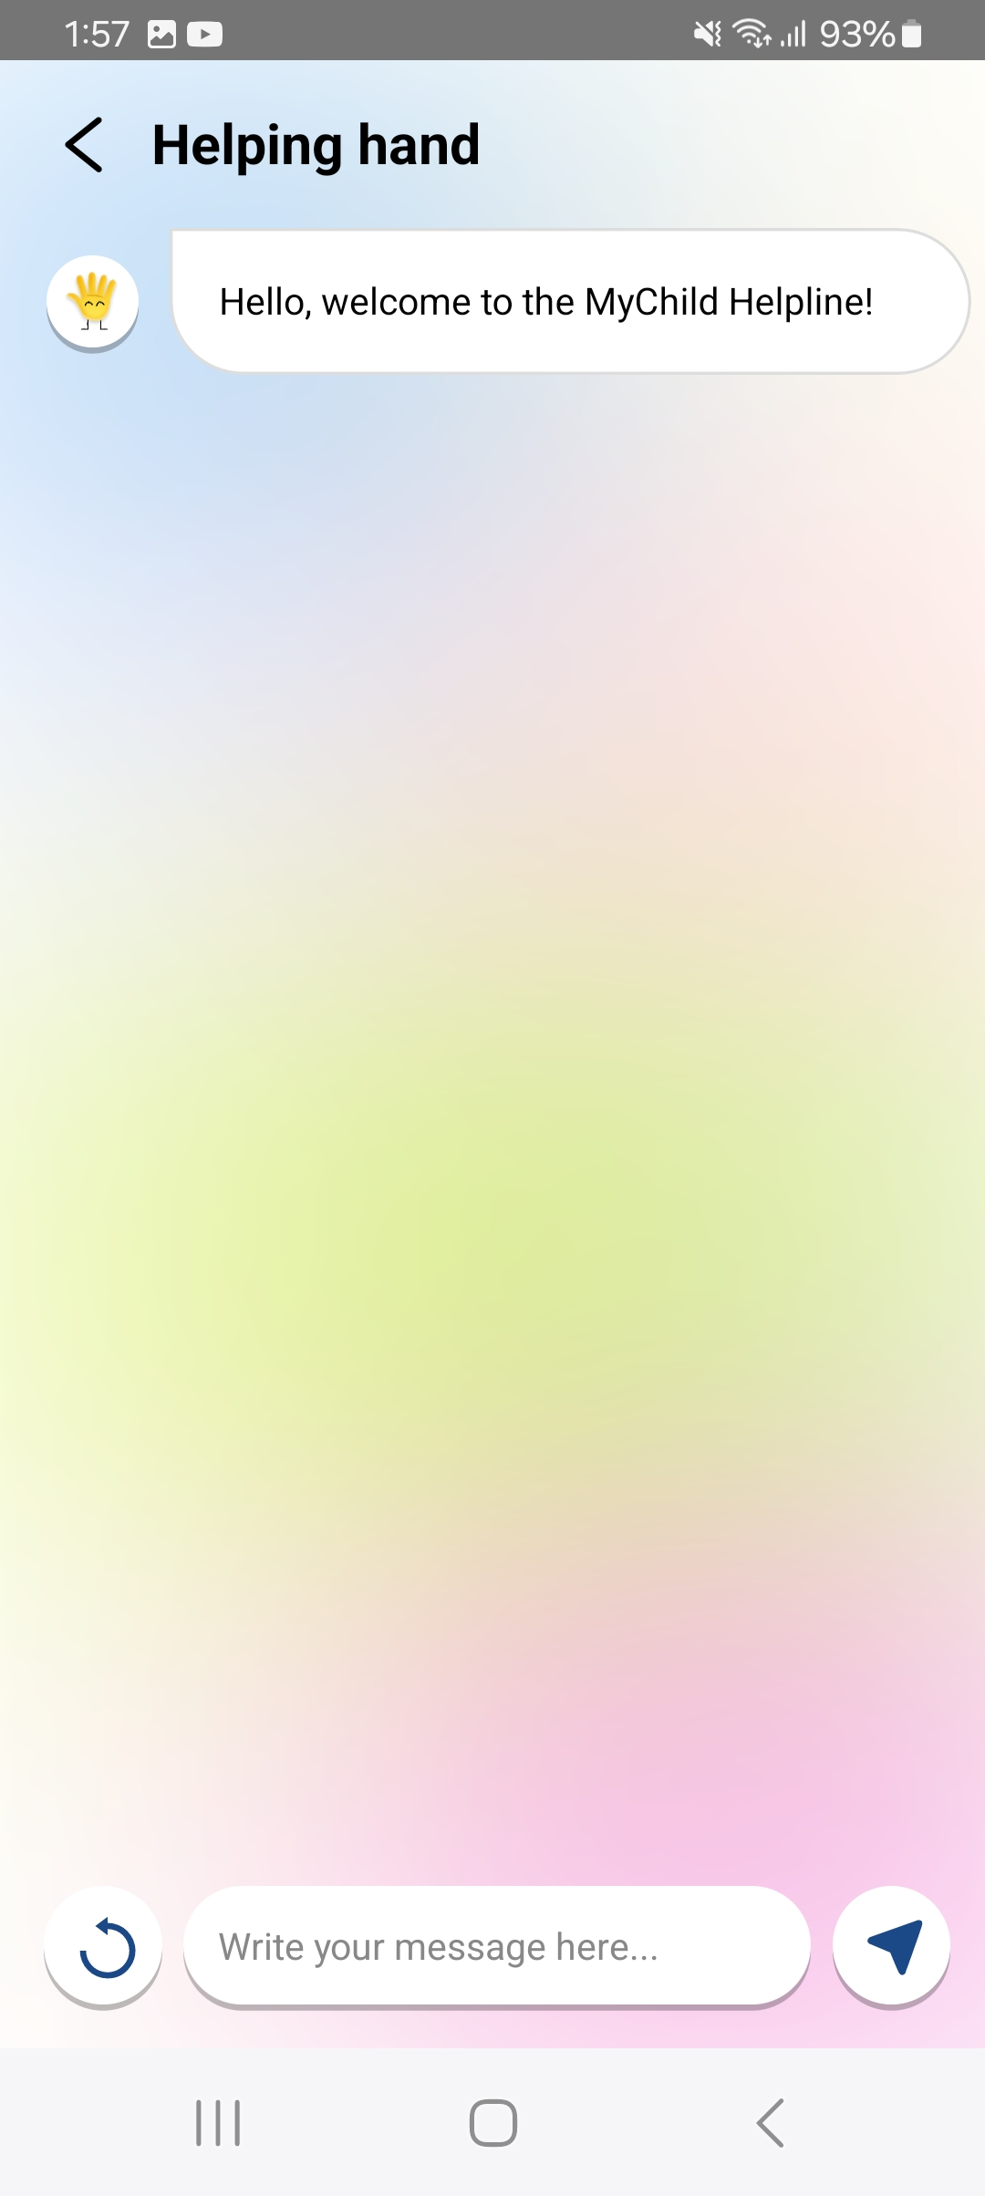

# CHAPTER 7: NOTIFICATION

The Notifications feature allows users to view important messages and announcements of their country. A bell icon at the top of the homepage displays a red dot when a new message is received, notifying users of new updates. Below is a step-by-step guide to use this module.

**Step 1:** Tap on the **“Bell”** icon available at the top right corner of the home page to view all the notifications received *(Refer to figure 7.1).*

**Step 2:** Tap on the “**Delete”** icon available at the top right corner to delete all the notifications once read (*Refer to figure 7.2).*

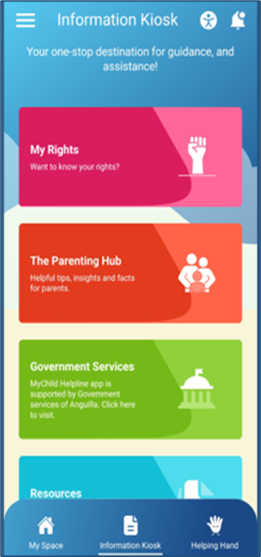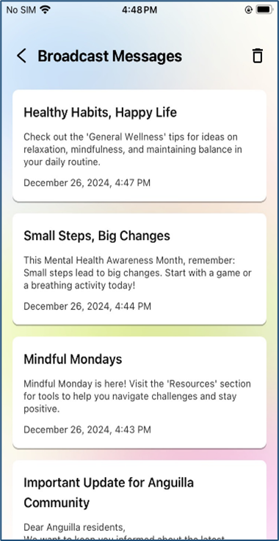

*Figure 7.1*

*Figure 7.2*

# CHAPTER 8: ACCESSIBILITY

The **Accessibility** feature is available at the top of all pages and provides options to enhance app usability for users with varying abilities. It includes adjustments for contrast, font size, and text spacing. Below is a step-by-step guide to use this module.

**Step 1:** Tap the Accessibility icon located at the top of any page to open the accessibility options *(Refer to figure 8.1).*

**Step 2:** To adjust the settings, perform the following actions *(Refer to figure 8.2)*:

* Tap on the **Dyslexia Friendly** option to adjust the contrast to make text and elements more visible.
* Tap on the **Bigger Text** option to manage the font size.
* Tap on the **Line Height** option to manage the space between lines of text.
* Tap on the **Text Spacing** option to adjust the spacing between characters and lines to enhance readability.

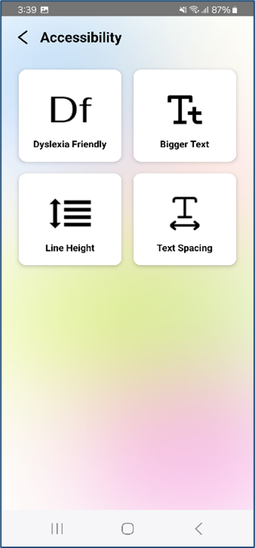

*Figure 8.1*

*Figure 8.2*

# CHAPTER 9: SETTINGS

The **Settings** module allows users to customize their profile, access important app information, submit feedback, view the privacy policy, and manage account settings. Below is a step-by-step guide to use this module.

**Step 1:** To update your profile, taponthe **main** menu button at top left to open settings**.**

**Step 2:** Tap on “**Update Your Profile”** option to open the profile update form *(as shown in Figure 9.2).*

**Step 3:** Tap on “**Profile Picture”** to select a new profile image or update the exiting Avatar.

**Step 4:** Update the following details under the profile update form:

* Tap on **Language** to Update your preferred language.
* Tap on **Gender** to Update or change your gender.
* Tap on **Country** to Update or change your country from the list.
* Tap on **District** to Update or change your district.
* Tap on **Date of Birth** to Update or change your date of birth.
* **Update Your Name** by entering the updated name.

**Step 5:** Tap on the “**Save”** button to confirm and save the changes.

*Figure 9.3*

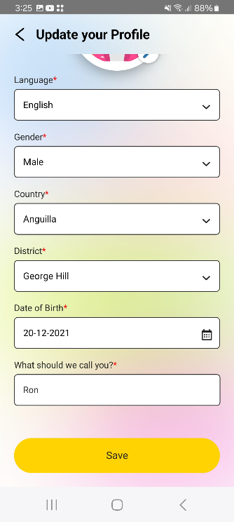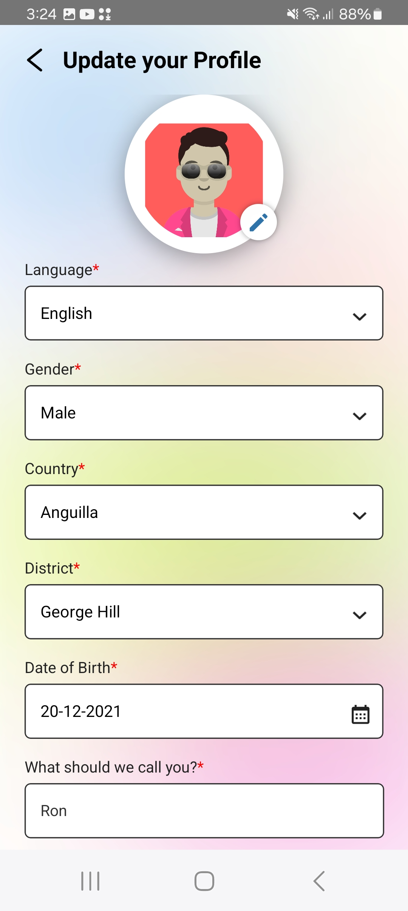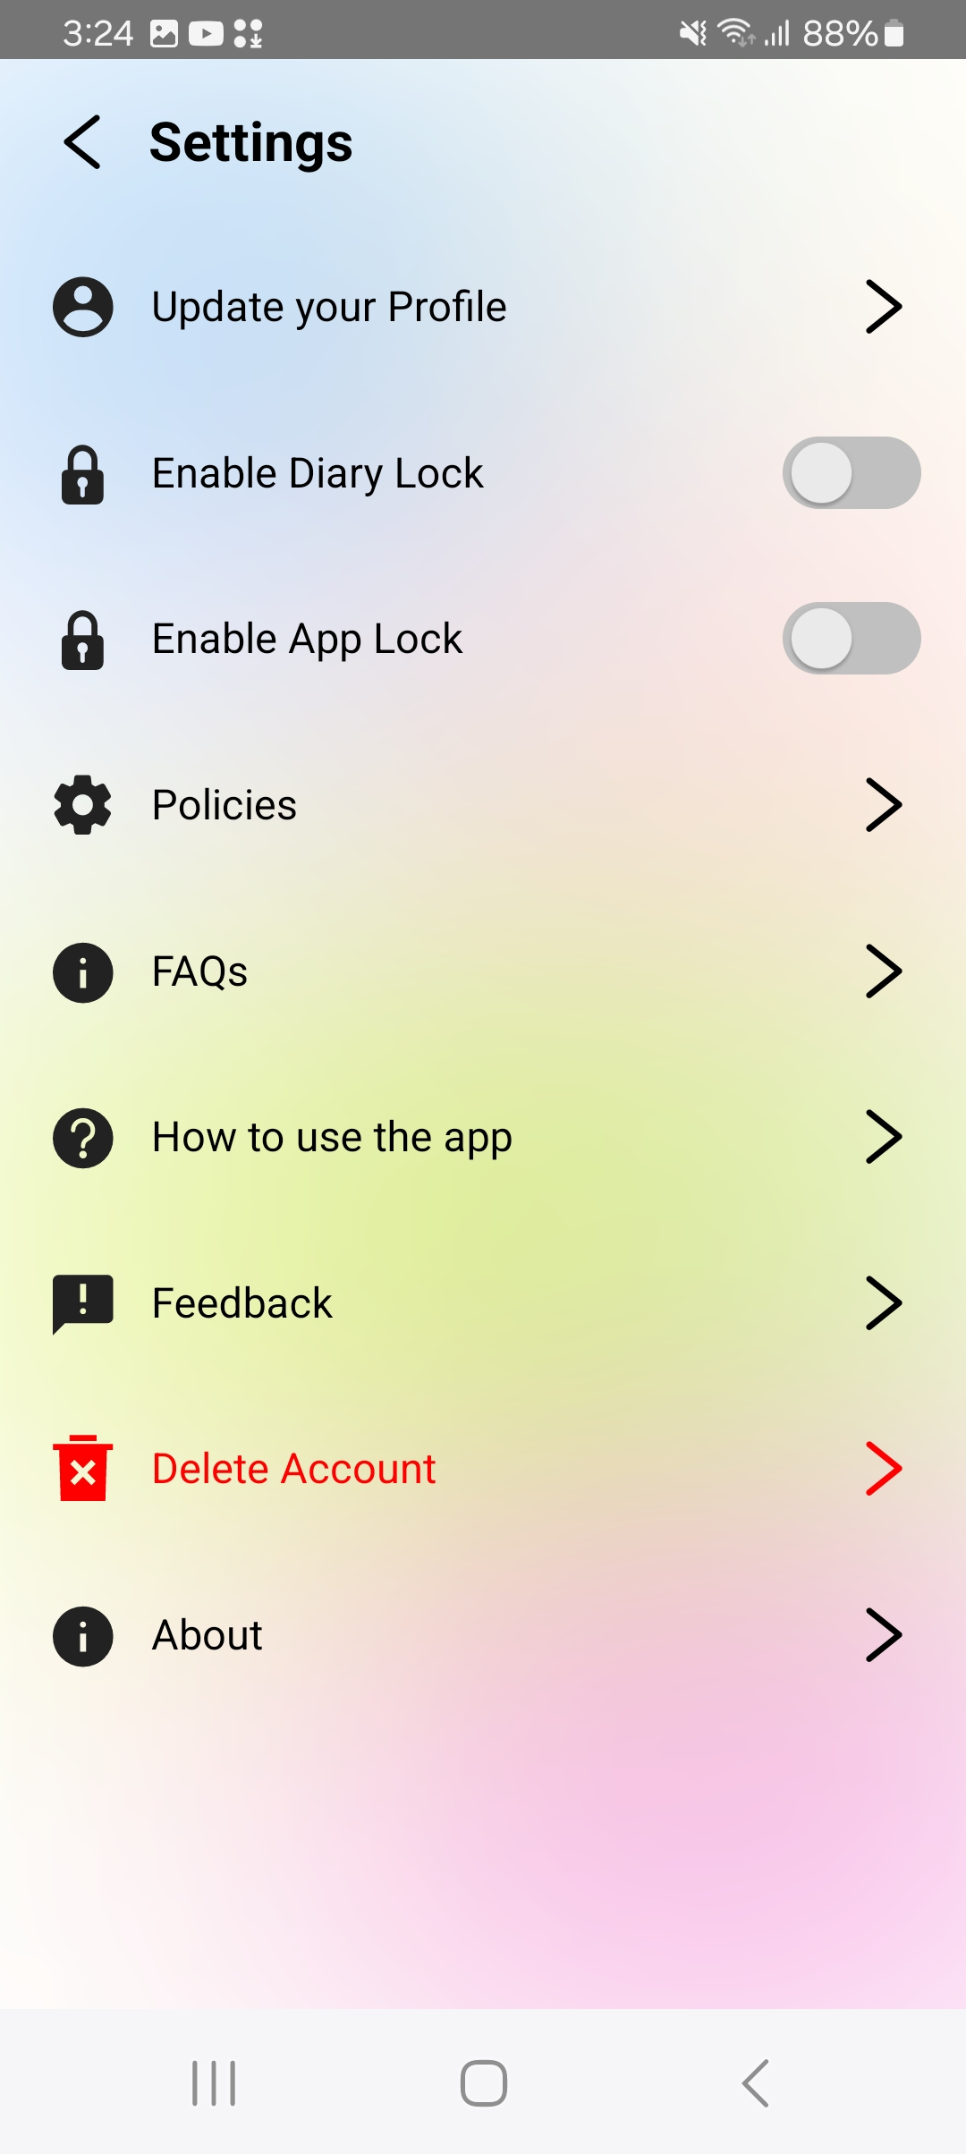

*Figure 9.1*

*Figure 9.2*

**Step 6:** Tap on the “**Enable Diary Lock**” option to activate a security lock for your diary.

**Step 7:** Tap on the “**Enable App Lock**” option to set a security lock for the entire app.

**Step 8:** Tap on the “**Policies**” option to view the terms, privacy policy, and other relevant guidelines governing the use of the app

**Step 9:** Tap on the “**FAQs**” option to access a list of frequently asked questions and find answers to common queries about the app’s features and usage.

**Step 9:** Tap on the “**How to Use this app**” option to view detailed instructions and guidelines on how to navigate and use the app.

**Step 10:** Tap on the “**Feedback**” option to submit your feedback by filling out and sending the feedback form.

**Step 11:** Tap on the “**Delete Account**” option to initiate the process of deleting your account. Follow the prompts to confirm your decision.

**Step 12:** Tap on the “**About**” option to view information about the app and access social media links for staying connected.

---- End of the document ----